Manifesto — James Cochrane for Middle, September 2026
James Cochrane

Manifesto
House of Keys · September 2026 · Independent Candidate for Middle
An Island our children are proud of, and choose to come home to.
Show the working · Track the promises · Say when I’m wrong

In two minutes
I’m standing because for years the Island’s plan has been to make one sector very wealthy and bend everything else to support it. Costs rose for everyone, and most of us are poorer for it. Here is what I’d do about it, in two minutes. The rest of this page is the full booklet.
- Economy. Back the things we can do at a competitive price from here, and get ferries, flights, parcels, electricity and broadband close to UK prices. We can’t devalue our way out, so our own costs have to come down, for households as much as for business.
- Housing. Homes first. One- and two-bed starter homes for first-time buyers; help-to-buy built for buying together; the 5,695 empty homes brought back; the landlord register made compulsory.
- Government. Own it, show it. One set of rules for projects and money; Chief Officers legally answerable; freeze back-office hiring now; accounts you don’t need an accountant to read; whistleblowers protected.
- Health. Stop reviewing, start doing. Fix the flow before adding beds; discharge sped up, with the care plan confirmed and funding settled after; published care pathways; bowel screening from 50, not 60.
- Later life. Growing old disgracefully. Care at home treated as care, not a savings plan; a fairer deal for the Hospice; an honest, grown-up conversation about how we pay for later life.
- Education. Kindness and community on the curriculum. PSHE that counts in every school; every child into a club or activity; critical thinking as the core skill; apprenticeships tied to the homes we build.
And what you can hold me to: a surgery every week, a non-judgemental ear, advocacy backed by data, my analysis published in the open, and a public corrections log.
House of Keys · September 2026 · Independent Candidate for Middle

About me
On the ballot paper: Julian Andrew James Cochrane
I’m Manx, raised in Rushen and schooled at CRHS. Mum’s a retired local primary teacher, herself raised opposite Knockaloe Beg Farm. I have two kids, and two remarkable cats from the MSPCA (shameless plug).
I’ve spent 30 years in industry after university: aeronautical engineering at the University of Glasgow and Imperial College London, later a Warwick Executive MBA, awarded with Distinction; its dissertation, on the Manx economy, was entered by the university into a national award. I’ve run change programmes in businesses large and small, including technology change in the Isle of Man Government.
My business partner and I bought out a Manx technology company and built it from a handful of people to over twenty; I sold my share last year. Today I work in data-driven capability, governance and change, running a public data observatory that demonstrates it with Government data. I also sit on the Department for Enterprise’s AI Advisory Group.

Local issues
- The TT Access Road: “not fit for purpose”, the Infrastructure Minister’s own words (2024). 320 more homes nearby won’t help matters. Decide it, cost it, build it.
- Safer roads through Santon, Marown and Mount Rule, settled by local consultation, not imposed.
- Safety on shared paths: cyclists owing people on foot the same space and care that drivers owe cyclists: slow down, pass wide.
- Braddan Woods: only 80 of 320 homes “affordable”, one in four, when affordability is the whole problem. Right-size what we build, and track the “maybes” in public.
These are just a few. More of the issues shared on the doorstep are addressed on this page and the pages behind it. Thank you for your time and your stories: many are unforgettable, some are difficult. I’ve listened, I’m grateful, and I don’t want to let any of you down.
Economy · the vision

What happened to Freedom to Flourish?
One sector boomed. Costs rose for everyone. Now the whole Island is paying.
The economy pays for everything: every nurse, teacher and road. Go off-Island and the difference is hard to miss: quieter high streets and tired shopfronts here, busier, brighter ones there. For years the Island’s plan has been to make one sector very wealthy and bend everything else to support it. We’re all paying for that now.
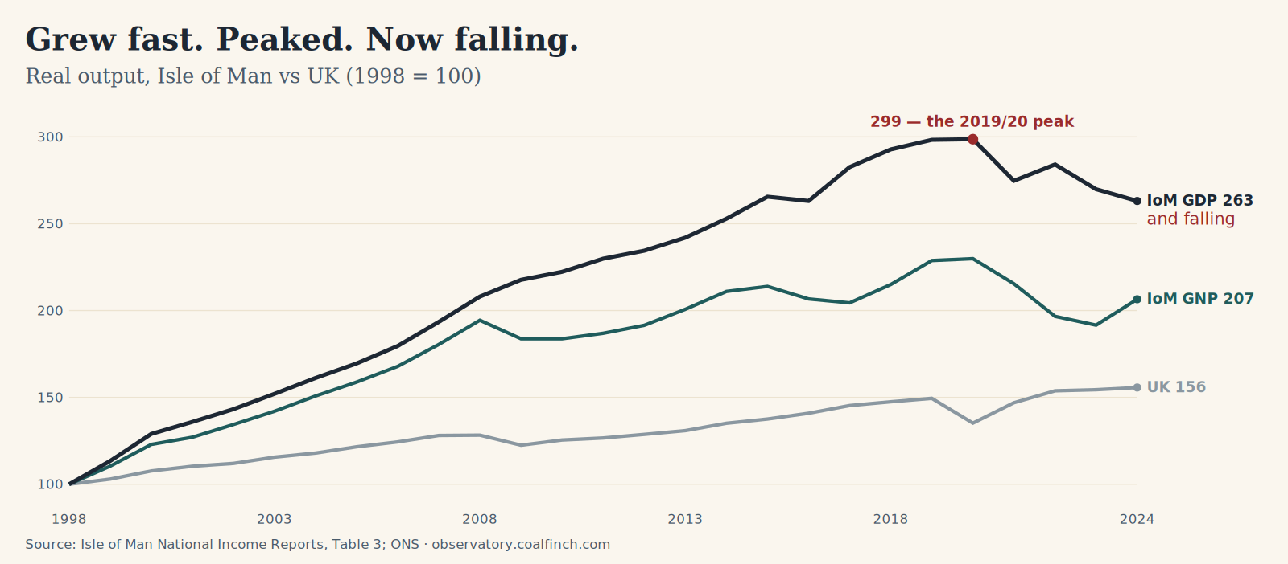 | In words: Line chart of real output indexed to 1998 equals 100: Isle of Man GDP rose to a peak of 299 in 2019/20 and has fallen to 263 by 2024; Isle of Man GNP is 207; the UK is 156. The Island grew far faster than the UK, then peaked and began falling.
Grew fast. Peaked. Now falling. Real output, Isle of Man vs UK (1998 = 100). Source: Isle of Man National Income Reports, Table 3; ONS.
The top line says we’re wealthier than the UK. Most of us aren’t. Output nearly tripled from 1998, peaked in 2019/20 and has been falling since, while the UK kept plodding upward. And the gap between the two Manx lines, what’s made here (GDP, 263) and what actually stays here (GNP, 207), is money booked on the Island that never reaches the people who live on it.

The vision
Stop relying on one sector, paid for by everyone else. Build an economy where every industry is investible, right across the Island. Growth, but not at any cost.
That means backing the things we can do at a competitive price from here, and working hard to keep them competitive. Fast, affordable internet for digital firms. Rules at least as good as Europe’s. And complementing Europe’s policy where it struggles to implement it, like data and privacy, where we already lead. And regulate by the numbers, not just the rulebook: watch prices and margins across the economy, and investigate where they stay stubbornly high.
Being competitive is practical, not just about rules. We’ll never be bigger than the UK, so the aim is to be close to UK prices: a business here only thrives if it can move goods, people, post, energy and data for about what a UK firm pays.
Ferries and flights are direct costs of doing business from the Isle of Man. A new Sea Services Agreement should seek to reduce these costs: freight prices and reliability regulated, independent oversight, the boat priced like supporting infrastructure, not a profit centre, and spare capacity carried for Manx farmers and firms at the incremental cost. And London must work as a day trip, so we can work toward hybrid IoM/South East careers in finance, tech and more.
Economy · the diagnosis

We’ve priced ourselves out.
From an economy built for one sector, to secure growth for all.
As e-gaming boomed it pushed up wages, property and prices across the board, and quietly squeezed other industries out. The Island is now too expensive for the rest of the economy to compete.
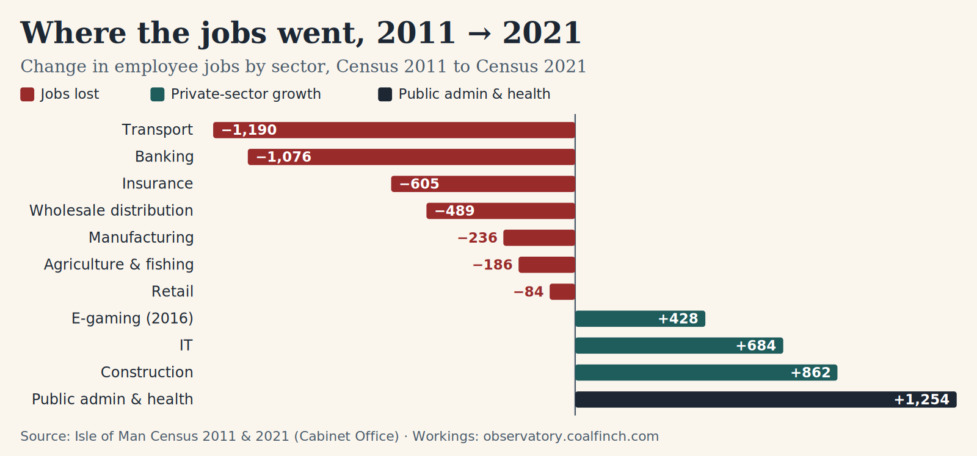 | In words: Diverging bar chart: change in Isle of Man employee jobs by sector between the 2011 and 2021 Censuses. Biggest losses Transport minus 1190, Banking minus 1076, Insurance minus 605. Biggest gains Public administration and health plus 1254, Construction plus 862, IT plus 684, e-gaming plus 428.
Where the jobs went, 2011 → 2021. Change in employee jobs by sector, Census 2011 to Census 2021. Source: Isle of Man Census 2011 & 2021 (Cabinet Office).

Since 2021
We’re still waiting for the 2026 Census to tell us how each sector is doing, so we vote without a current picture. What we do know:
- The Island’s National Accounts show the economy shrank 7.4% in the two years to March 2024: a bigger fall than the UK suffered in the 2008 crash.
- The Chamber of Commerce counts around 1,000 jobs lost from key sectors in two years: the worst decline in a generation.

The diagnosis
A country in this position would normally let its currency fall to get cheaper. We can’t: we use the pound and import most of what we buy. The only thing we control is our own costs, and they have to come down, for households as much as for business. Energy, groceries, fuel and mortgages all cost more here than they should, because there’s too little competition to stop it, and high costs hit every sector, hardest the ones most exposed to competition: retail, agriculture, hospitality. It’s also why young people can’t afford a family here.
And the most distorted cost of all is a home. So that’s where we start.
Housing

Homes first. Then people. Then growth.
Housing is the Island’s most distorted cost, and it sits under everything else: wages, business costs, and every young family’s decision on whether to stay. On a full island, the one lever that adds instead of just swapping who lives here is supply. So we start by making homes available.
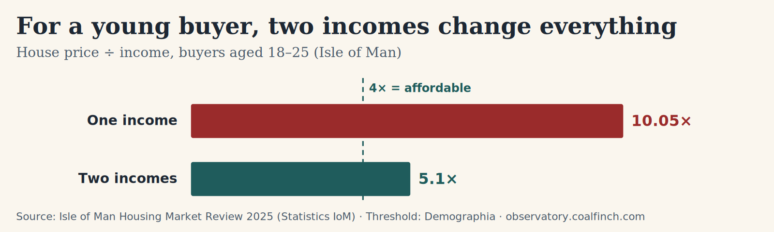 | In words: Bar chart: for Isle of Man buyers aged 18 to 25, a home costs 10.05 times a single income but only 5.1 times a joint two-income household. The affordability threshold is 4 times.
For a young buyer, two incomes change everything. House price ÷ income, buyers aged 18–25 (Isle of Man). Source: Isle of Man Housing Market Review 2025 (Statistics IoM); threshold: Demographia.
5,695 homes were recorded as vacant at the Census, 13% of the stock. So this isn’t only about how many homes we have, but where and how they’re held. Build what we’re short of, bring the empties back, and stop letting homes be somewhere to park capital rather than somewhere to live.
Why this is urgent. It is already happening: since 2016 deaths have outnumbered births every year, and school rolls are falling (11,569 pupils in 2020/21 to 11,079 now), the leading edge of a dependency ratio heading for 87.7 per 100 working-age residents by 2075 on flat migration. Homes are how we keep working-age families here.
- More starter homes: one- and two-bed, built for first-time buyers, plus single-person homes that make downsizing attractive.
- A tradesperson-led self-build scheme, conditioned on taking on apprentices: building homes and rebuilding the trades in one move.
- Help-to-buy built for buying together. A typical home is 10× one young income but 5× two: steep, but reachable. So build the scheme around two people buying jointly, not one.
- Bring the empties back: publish the breakdown behind the 5,695 vacant homes, and back only right-sized homes until we know categorically what’s consuming the stock.
- Make the landlord register compulsory: the 2021 Act is on the books, but five years on the register is still only voluntary.
- A housing fund with its money committed for several years up front, not topped up year to year, so support can’t stop and start mid-purchase.
- Break the housing costs that quietly compound (mortgage margins, land-banking, rents), part of taking on market power and concentration right across the economy.
Build the homes, and the rest follows: people, community, and a reason for the next generation to stay.
Government

Own it. Show it.
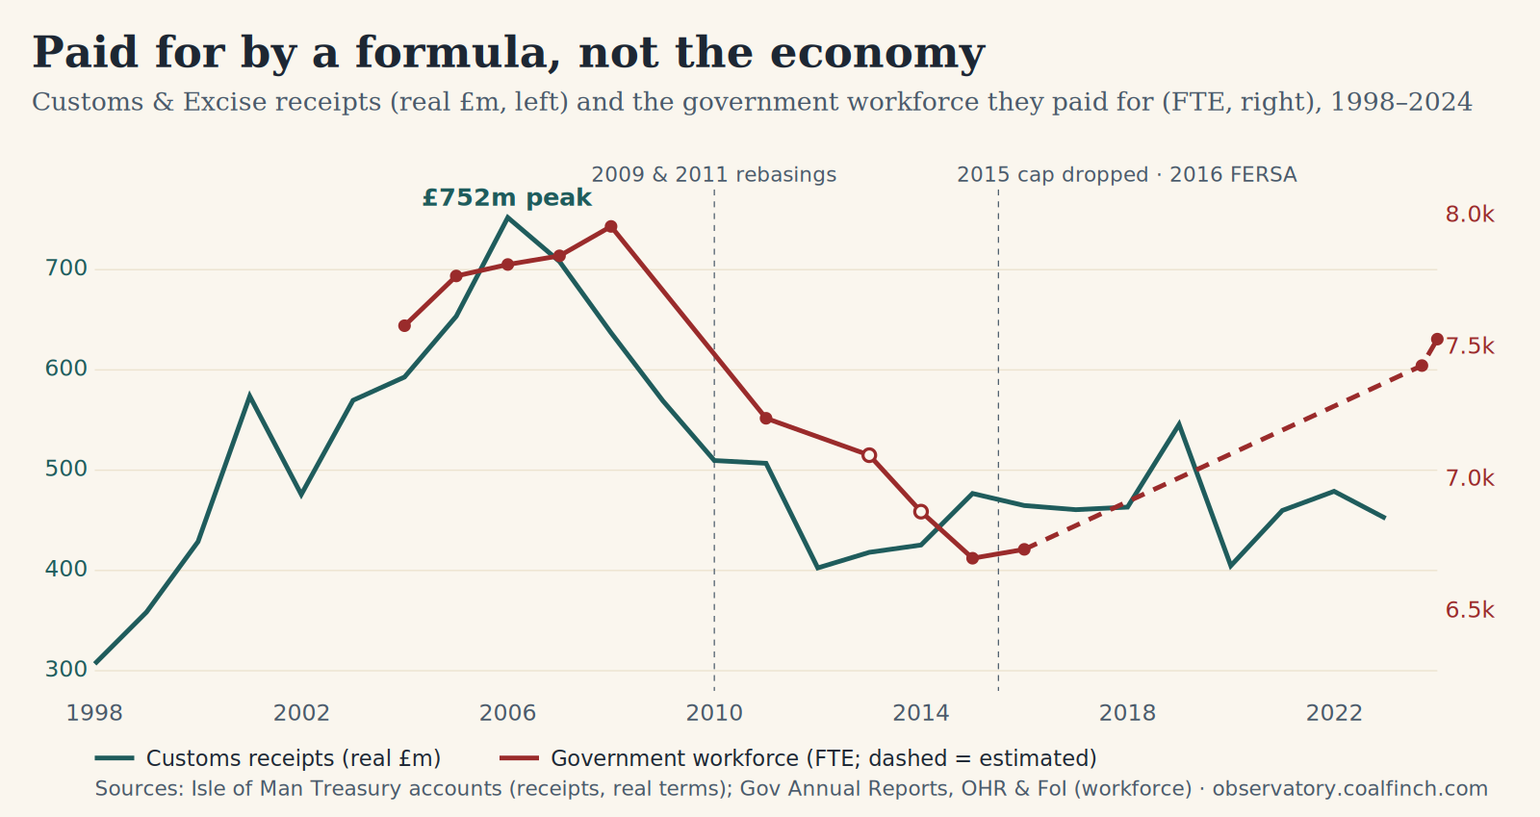 | In words: Dual-axis line chart: Isle of Man Customs and Excise receipts in real terms peaked at 752 million pounds in 2006 then fell to about 400 million by 2012 after the 2009 and 2011 rebasings; the government workforce followed the receipts down to 2015, then climbed from 6,737 in 2016 to 7,533 by 2024 while receipts stayed flat around 460 million.
Paid for by a formula, not the economy. Customs & Excise receipts (real £m) and the government workforce they paid for (FTE), 1998–2024. Sources: Isle of Man Treasury accounts; Government Annual Reports, OHR and FoI.
There aren’t many of us to go round, and three things compete for the same workers: Government, the sector we chose to back (e-gaming), and everyone else. Government grew on VAT and duties shared with the UK that were never guaranteed, and when those receipts fall the wage bill has to follow. The population has been flat since 2011, yet we employ more Government workers than we did then: by that standard, the system is no more efficient than it was 15 years ago. Every role that moves from a public desk to a productive private job pays back twice: a cost becomes income and tax, once private pay is good enough to draw people across. My working hypothesis: too much of the structure manages upwards rather than serving outwards; the fix is a responsive front line, less middle management, and community hubs extended.
I’ll be one voice in the Keys, and I won’t pretend otherwise. But one voice with the numbers can move things. I’d rather win the argument on the evidence, and win over the civil servants who have to deliver it, than trade my vote for a seat at the table. My first ask of the new House: a proper, evidence-led analysis of the options, done in the open, so the programme for government is built on what works, not on horse-trading.
- Clear rules, kept in one place. One simple set of governance rules for projects and money, used by every department. The Liverpool ferry terminal (budgeted at £18m, £70.7m by the time Tynwald’s own Public Accounts Committee called it “inadequately planned”) is what happens without them.
- Accountability with teeth. Chief Officers and Directors legally answerable for keeping their department’s finances sound.
- Freeze, then cap. Stop hiring for back-office roles now (frontline exempt), and bring back the Government headcount limit dropped in 2015, when the time is right.
- Count properly. Most people who lose their job don’t qualify for Jobseeker’s Allowance, so they never appear in the figures: the headline unemployment number badly understates how many are out of work.
- Numbers you can read. Government accounts to a recognised standard (IFRS or GAAP), readable without an accountant; National Accounts reported to the IMF standard; and public data shown in ways people can actually use.
- Independent oversight, and whistleblowers protected, full stop. The Island had no Auditor General until 2021, and this year’s reforms were watered down. A truly independent way to raise concerns. Whistleblowers should be protected.
Health & later life

Stop reviewing. Start doing.
We’ve paid for the diagnosis. Now act on it.
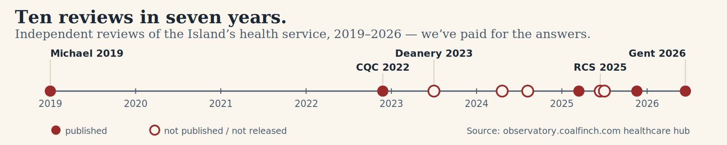 | In words: Timeline of ten independent reviews into the Isle of Man health service between 2019 and 2026: Michael 2019, CQC 2022, Deanery 2023, RCS Surgery 2025, Gent 2026 among them, clustering heavily in 2024 to 2026.
Ten reviews in seven years. Independent reviews of the Island’s health service, 2019–2026. Source: observatory.coalfinch.com healthcare hub.
Ten reviews in seven years, bought and paid for. We just need to complete the actions they identified.
- Fund the formula the reviews set, and hold it there. You can’t run the biggest change programme in the service’s history on a cut budget.
- Shielded politically, properly. The governance, delegation and contracting work the reviews identified needs completing, not resetting with every new minister.
- The block isn’t social care being full: it’s how long discharge takes. Give clinicians confidence a care plan is genuinely in place, so they can send patients on without fear.
- Care arranged before finance. No one should block a ward bed while their care funding is decided: arrange the care, discharge, settle the money after.
- A networked hospital: specialists visiting and by telemedicine, capacity and outcomes shared and benchmarked with Jersey and Guernsey, patients travelling only when they truly must.
- Published care pathways, in the open: see the route and take the steps you can yourself, not wait on Manx Care when you needn’t. Employed GPs, with GP and hospital data joined up.
- Leadership clinicians trust, and pay benchmarked to recruit and keep the staff we’re short of.
- Prevention pays: screen earlier, bowel cancer from 50 not 60, catching cancers where nine in ten survive, not one in ten. A monitored prevention budget line, with cervical and bowel screening coverage published against international best practice.
- Mental health: the biggest movable lever is economic exclusion; work, money and purpose are part of the cure, alongside proper clinical services.
- Integrated women’s health: endometriosis, menopause and the mental health alongside them, on published pathways, not waiting lists.
A model, not a headcount. Every clinician knows what happens when digestion is blocked. This is a hospital system with the same problem: fix the flow before adding beds, or new beds “fill almost immediately”. Every figure in the diagram below is a modelled result from my system-dynamics model of Noble’s flow, not a live count.
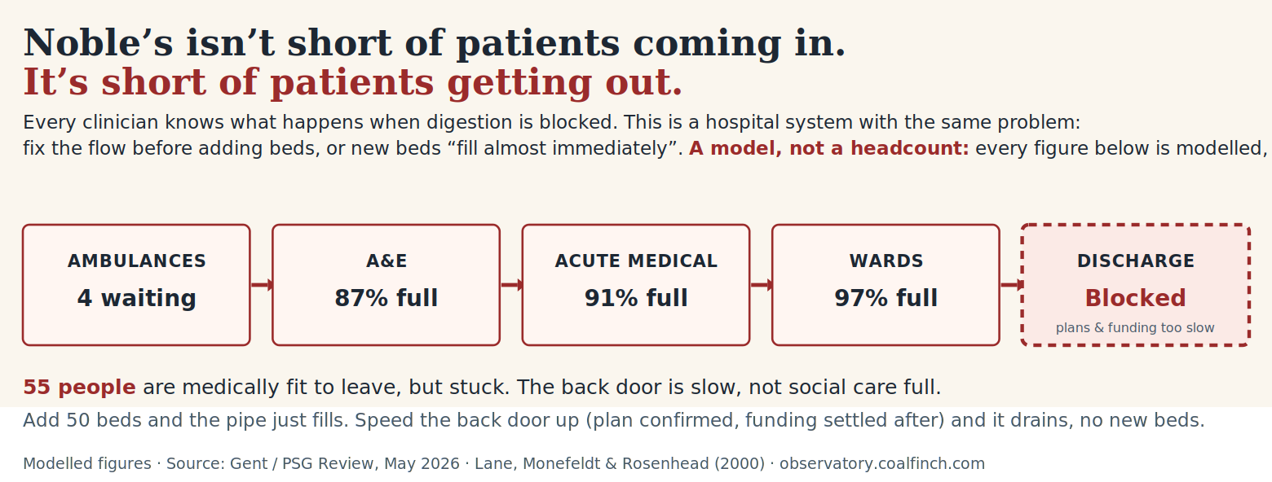 | In words: All figures are modelled results, not live counts. Like a digestive system blocked at the exit: patients flow from ambulances (4 waiting) through A and E (87% full), acute medical (91% full) and the wards (97% full) to a blocked discharge back door, where care plans and funding decisions take too long. 55 people are medically fit to leave but stuck. Add 50 beds and the pipe just fills; speed the back door up, plan confirmed and funding settled after, and it drains with no new beds. Source: Gent / PSG Review May 2026; Lane, Monefeldt and Rosenhead (2000).
All figures are modelled. Noble’s isn’t short of patients coming in. It’s short of patients getting out. 55 people are medically fit to leave but stuck; add 50 beds and the pipe just fills again; speed up discharge, care plan confirmed and funding settled after, and it drains with no new beds. Source: Gent / PSG Review, May 2026; Lane, Monefeldt & Rosenhead (2000).
Health & later life

Growing old disgracefully.
Care, community and homes that make later life something to look forward to.
The Island is ageing, and mostly it’s us: a bubble of the people working here now, growing older together, not a wave of retirees moving in; this isn’t recent immigration, it’s the result of decisions taken decades ago. We have far fewer people in their twenties and thirties than the UK, and many more in their fifties and sixties. An economy skewed to one sector pushes homes out of reach of the young, and the young off the Island, ageing us faster still. Not a crisis to fear, a future to plan for.
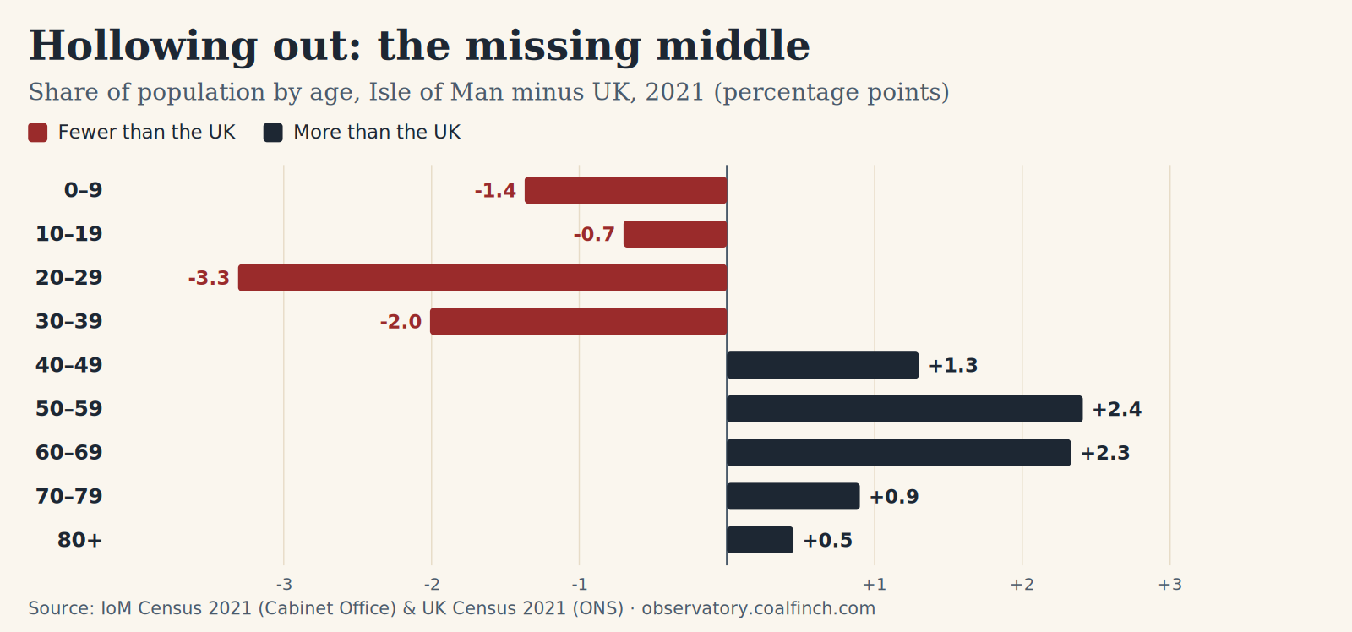 | In words: Diverging bar chart: how the Isle of Man population differs from the UK by age in 2021, in percentage points. The Isle of Man has far fewer people in their twenties (minus 3.3 points) and thirties (minus 2.0), and more in their fifties (plus 2.4) and sixties (plus 2.3).
Hollowing out: the missing middle. Share of population by age, Isle of Man minus UK, 2021 (percentage points). Source: IoM Census 2021 (Cabinet Office) & UK Census 2021 (ONS).
- Care at home treated as care, not a savings plan.
- A fairer deal for the Hospice. In March it made staff redundant and handed four services to Manx Care after six years of deficits. Government pays 24% of its income (Jersey pays 44%, the UK average is 36%) and this year’s grant rose by less than costs. Care this essential, that pays back this kindly, and is still mostly funded by charity, deserves a proper public share, as our neighbours already manage.
- How we pay for later life: an honest, grown-up conversation about pensions, care and its costs; straight talk, not another consultation. England is considering a National Care Service, built on exactly our hardest question: care run to the standard of health. Watch it closely, and bring here what works.
- Work and purpose don’t retire at 65. Part-time paid care, childcare, advocacy, helping people through grief, loss and trauma, mental-health roles: work that runs on exactly what later life has in abundance, experience, love and heart.
- Later life worth looking forward to: community, activity and things to do, not just care.
- Homes that make downsizing attractive: less house to run, more time to live, and a family home freed for the next generation.
- Pensions, public-service and State alike, held to one open standard: the same scrutiny of what they cost, and the same protection of what people are owed. No more needless divisiveness.
Education

Kindness and community on the curriculum.
If the world our children inherit leans harder on screens and AI, the schooling that matters most is the part a machine can’t do: empathy, judgement, resilience and knowing how to be with other people. Less screen-time, more people-time. We don’t need children who can lean on AI; we need children who don’t have to.

The human skills
- Make PSHE and RSHE genuinely mandatory and consistent across every school, with the opt-out limited to the sex-education part. This is how a community builds resilience early: our best prevention for mental ill-health.
- Healthy relationships: respect, boundaries and consent, and the confidence to know when something isn’t right.
- How other people think: neurodiversity understood and included, not just tolerated.
- Recognising problems: spotting distress in yourself and others, and how to listen and step in.
- Kindness and belonging: every child into a club or activity, 11–16, with Year 9 community projects that let teenagers show their best.
- Proactive family law: every separation involving children handled by a child-centred service, paid for by the crises it prevents. Shared care the default where safe, the limbo ended within 26 weeks.

The hard skills
- Critical thinking as the core skill, with tech for everyone built around it: knowing when AI helps, and when it doesn’t.
- Apprenticeships tied to real planning and building projects: the trades we rebuild to build the homes.
- Long-term workforce planning for clinical roles, backed by state funding: grow our own clinicians and carers.
- Funded, paid Care Certificates for school leavers and willing retirees: routes into care, rehabilitation, advocacy and mental-health roles.
- Medium term, a proper recruitment programme for the civil service: grow the skills Government needs instead of renting them.
- SEN (additional educational needs): the code meant to guarantee support was drafted in 2020 and never made law. Finish the Bill, make it statutory, publish the waiting times. Actively researching.

The things you can hold me to
- A surgery every week: Santon, Braddan, Ballafletcher and Marown, in turn.
- A non-judgemental ear, on your side.
- Supportive, not antagonistic. Present, not absent.
- Advocacy and challenge, backed by data and delivery experience.
- My own analysis on the critical issues, published, and open to challenge.
- A public corrections log: when I’m wrong, I say so.
Thank you for reading.
Polling day is Thursday 24 September. If this is the kind of representation you want, I’d be grateful for one of your two votes.
07488 559 428 · james@cochrane.im · www.cochrane.im
An Island our children are proud of, and choose to come home to.
Published by James Cochrane, Thie ny Shee, 10 Keeill Pharick Park, Glen Vine, Isle of Man, IM4 4EW
07488 559 428 · james@cochrane.im · www.cochrane.im

